BUILDING your PhoneGap App
https://build.phonegap.com/ dpercoco@comcast.net/A11e1u1a*
https://github.com dpercoco@comcast.net/A11e1u1a*
https://github.com/dpercoco/Tusk/

Using Appery (https://appery.io ;dpercoco@comcast.net/1nv13rn0
https://devcenter.appery.io/tutorials/building-a-mobile-rss-app/
https://devcenter.appery.io/tutorials/uploading-files-to-appery-io-database/
https://devcenter.appery.io/documentation/app-settings/
https://devcenter.appery.io/tutorials/building-mobile-app-with-user-registration/
https://devcenter.appery.io/tutorials/building-a-simple-todo-app-with-appery-io-backend-services/
https://devcenter.appery.io/documentation/mapping/ (Error handling)
Using Cordova
http://codingsquare.blogspot.com/2013/08/creating-cordova-3-android-project.html
http://cordova.apache.org/docs/en/5.0.0/guide_hybrid_plugins_index.md.html#Plugin%20Development%20Guide
Eclipse IDE Project folder: c:\users\p62680o\AndroidTusk\platforms\android
Android SDK folder:
C:\MyApps\MobileApps\Android\sdk
http://stackoverflow.com/questions/6376722/failed-to-install-apk-on-device-emulator-5554-eof
http://cordova.apache.org/docs/en/2.4.0/cordova_storage_storage.md.html
https://iphonedevlog.wordpress.com/2014/04/07/installing-chris-brodys-sqlite-database-with-cordova-cli-android/
https://www.sqlite.org/cli.html
http://jquerymobile.com/download/

PHP
http://windows.php.net/download/
http://www.developer.com/ws/android/programming/Build-Your-First-PHP-for-Android-Application-3904261.htm
http://blog.teamtreehouse.com/beginners-guide-to-ajax-development-with-php
http://www.sitepoint.com/use-jquerys-ajax-function/
http://stackoverflow.com/questions/15757750/php-function-call-using-javascript
http://stackoverflow.com/questions/15696440/connecting-to-a-mysql-database-using-phonegap-ajax-and-jquery-mobile
https://iphonedevlog.wordpress.com/2014/03/28/populate-your-phonegap-app-with-data-from-an-external-server-db/
http://www.w3schools.com/php/php_mysql_connect.asp
http://stackoverflow.com/questions/27201533/php-pass-multiple-parameters-on-success-in-ajax-call
http://www.tutorialspoint.com/android/android_php_mysql.htm

<a href="../nav.html" data-icon="search" data-iconpos="notext" data-rel="dialog" data-transition="fade">Search</a>
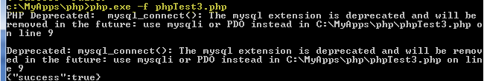
Local Storage
http://www.w3schools.com/html/html5_webstorage.asp

Using Cordova - Development
http://www.coderzheaven.com/2011/04/17/using-sqlite-in-android-a-really-simple-example/
http://www.sqlite.org/docs.html
http://www.sqlite.org/cli.html (Client commands)
http://stackoverflow.com/questions/6120424/android-copy-database-from-asset-folder-but-only-get-an-empty-file
http://coenraets.org/blog/2011/10/sample-app-using-the-phonegap-database-api/
http://stackoverflow.com/questions/2727763/communication-between-android-java-and-phonegap-javascript
https://theredneckcoder.wordpress.com/2013/04/30/mobile-feed-reader-app-part-2-create-rss-reader/
http://code.tutsplus.com/tutorials/jquery_android--mobile-4720
https://github.com/apache/cordova-plugin-file/blob/master/src/ios/CDVAssetLibraryFilesystem.m
https://github.com/apache/cordova-plugin-file/pull/84
https://github.com/jgilfelt/android-sqlite-asset-helper/blob/master/samples/database-v1/src/main/java/com/example/MyDatabase.java

The SQLite plugin provides a persistent local data storage. The db locations should be as follows:
- For Android - /data/data/{app.package}/databases/ or /data/data/{app.package}/app_database/
- For iOS - Document Folder/Your App Docs/
- Use local storage for storing userid (window.localStorage)
  - window.localStorage.setItem("key", "value");

http://cordova.apache.org/docs/en/5.0.0/config_ref_index.md.html#The%20config.xml%20File (configuring for IOS)
http://webdesign.tutsplus.com/articles/a-tale-of-two-platforms-designing-for-both-android-and-ios--cms-23616
http://devgirl.org/2013/11/12/three-hooks-your-cordovaphonegap-project-needs/
http://www.techrepublic.com/blog/software-engineer/create-cross-platform-apps-with-phonegap-and-jquery-mobile/ (Contacts List)
http://phonegap-plugins.com/plugins/monday-consulting/contactchooser

(Copying images to IOS folder)
http://mashable.com/2010/07/13/mobile-web-optimization/ (testing across platforms)
https://developer.apple.com/library/ios/documentation/UserExperience/Conceptual/MobileHIG/index.html#//apple_ref/doc/uid/TP40006556-CH66-SW1 (developing for IOS)
http://stackoverflow.com/questions/8326272/access-files-from-assets-www-directory
ICONS
http://findicons.com/icon/258871/cancel?id=258871
http://api.jqueryui.com/theming/icons/

Developing a PlugIn
http://cordova.codeplex.com/ ****
http://devgirl.org/2013/07/17/tutorial-how-to-write-a-phonegap-plugin-for-android/ ****
http://stackoverflow.com/questions/9414633/how-to-access-database-using-phone-gap ****
https://developer.ibm.com/mobilefirstplatform/documentation/getting-started-6-3/adding-native-functionality/android-adding-native-functionality-hybrid-application-apache-cordova-plugin/
https://blogs.oracle.com/mobile/entry/introduction_to_custom_cordova_plugin
https://github.com/don/cordova-plugin-hello
https://cordova.apache.org/docs/en/4.0.0/guide_hybrid_plugins_index.md.html
http://docs.phonegap.com/en/edge/cordova_notification_notification.md.html
https://ccoenraets.github.io/cordova-tutorial/native-notification.html ****
https://cordova.apache.org/docs/en/4.0.0/guide_cli_index.md.html
JQuery validation
http://demos.jquerymobile.com/1.2.0/docs/api/data-attributes.html
http://demos.jquerymobile.com/1.0a4.1/docs/buttons/buttons-icons.html
http://jqueryvalidation.org/
http://jqueryvalidation.org/category/plugin/
http://jqueryvalidation.org/files/demo/
http://www.sitepoint.com/basic-jquery-form-validation-tutorial/
http://www-01.ibm.com/support/knowledgecenter/SS8PJ7_9.1.2/com.ibm.hybrid.mobile.doc/tutorials/hmsplashscreen2.html
http://demos.jquerymobile.com/1.2.1/docs/toolbars/footer-persist-a.html (Themes, footer)
http://www.toptal.com/mobile/developing-mobile-applications-with-apache-cordova
http://stackoverflow.com/questions/12983869/how-to-open-a-new-html-page-using-jquery (open HTML page)
http://stackoverflow.com/questions/15696440/connecting-to-a-mysql-database-using-phonegap-ajax-and-jquery-mobile
http://makeappicon.com/
http://codyhouse.co/gem/css-slide-in-panel/
http://stackoverflow.com/questions/19392453/jquery-show-hide-sliding-panel-from-left-side
http://johnchacko.net/?p=108 (sample panel)
http://demos.jquerymobile.com/1.3.0-beta.1/docs/panels/
http://www.zazar.net/developers/jquery/zrssfeed/
http://www.sitepoint.com/jquery-current-page-url/
https://api.jquerymobile.com/data-attribute/
http://www.w3schools.com/html/html5_webstorage.asp (click count)
RSSContent
https://www.mnot.net/rss/tutorial/

InAppBrowser
https://github.com/apache/cordova-plugin-inappbrowser
http://docs.phonegap.com/en/edge/cordova_inappbrowser_inappbrowser.md.html
http://cordova.apache.org/docs/en/3.2.0/cordova_inappbrowser_inappbrowser.md.html
https://github.com/initialxy/cordova-plugin-themeablebrowser
https://www.npmjs.com/package/cordova-plugin-inappbrowser
http://stackoverflow.com/questions/29366485/get-page-title-in-themeablebrowser-cordova-phonegap
http://stackoverflow.com/questions/23193685/is-it-possible-to-add-buttons-and-control-its-event-to-toolbar-of-inappbrowser-u
http://blog.jibebuy.com/2014/08/custom-webviewinappbrowser-for-ios-and-android-for-cordova-phonegap-app/
Swipe
http://stackoverflow.com/questions/17773697/gmail-like-listview-item-removing-jquerymobile
http://stackoverflow.com/questions/13876149/how-do-i-add-this-working-swipe-delete-functionality-to-a-new-appended-list-item
http://andymatthews.net/read/2012/02/19/swipeButton-jQuery-Mobile-plugin-launches.-Millions-rejoice!
https://api.jquerymobile.com/swipe/
http://demos.jquerymobile.com/1.3.2/examples/swipe/swipe-list.html
https://github.com/commadelimited/jquery.swipeButton.js/blob/master/swipe-1.1.html
https://forum.jquery.com/topic/get-image-url-from-media-content-in-rss-xml-feed-20-9-2012
https://learn.jquery.com/jquery-ui/getting-started/ (using ThemeRoller)
https://forum.jquery.com/topic/listview-refresh-does-not-work
http://stackoverflow.com/questions/27198041/jquery-function-on-dynamically-created-list-not-working-solved

ScreenScraping
http://stackoverflow.com/questions/5667880/simple-screen-scraping-using-jquery

August 2015
http://code.tutsplus.com/tutorials/phonegap-build-a-feed-reader-project-structure--mobile-20265
http://stackoverflow.com/questions/21355991/change-the-background-color-of-listview-item-when-its-selected-in-jquery-mobile
http://stackoverflow.com/questions/4143097/multiple-buttons-in-the-header
https://software.intel.com/en-us/articles/phonegap-contacts-work-with-the-devices-contact-database
http://stackoverflow.com/questions/25380633/deleting-all-the-contacts-in-phonegap-android
http://stackoverflow.com/questions/1328723/how-to-generate-a-simple-popup-using-jquery
https://cordova.apache.org/docs/en/3.0.0/cordova_contacts_contacts.md.html

- Register.html: fix popup
http://stackoverflow.com/questions/5267569/display-messages-with-jquery-ui
- Login.html: fix pop
- Remove gray circle from icons:
http://stackoverflow.com/questions/4143097/multiple-buttons-in-the-header
Installing PlugIns
Command line prompts:
- cd c:\MyApps\MobileApps\Eclipse\Tusk
- npm view cordova versions
- npm config set strict-ssl false
- npm install –g cordova@3.6.3-0.2.13, 3.6.0-0.2.8
- cd c:\MyApps\MobileApps\Eclipse
- cordova create Tusk com.cordova.tusk Tusk
- cd Tusk
- cordova platform add android
- cordova theme add android
- cordova plugin remove org.apache.cordova.splashscreen
- cordova plugin add org.apache.cordova.splashscreen **
- cordova plugin add org.apache.cordova.dialogs **
- Cordova plugin add C:\Users\p62680o\Downloads\MobileApps\cordova-plugin-inappbrowser-master
- Cordova plugin add org.apache.cordova.contacts
Example: https://github.com/cfjedimaster/Cordova-Examples/tree/master/contactpickerui
Example: http://www.raymondcamden.com/2014/07/09/Cordova-Plugin-update-and-new-Contacts-demo
Example: http://www.raymondcamden.com/2014/12/23/cordova-demo-viewing-all-contacts, https://ccoenraets.github.io/cordova-tutorial/contacts-api.html
- Cordova plugin add C:\Users\p62680o\Downloads\MobileApps\phonegap-facebook-plugin-master --variable APP_ID="759720284139421" --variable APP_NAME="Tusk"
- plugman install --platform android --project c:\MyApps\MobileApps\Eclipse\Tusk\platforms\android --plugin cordova-sqlite-storage
- cordova plugin ls
- npm config set strict-ssl true
- cordova build
add feature → res\xml\config.xml
Also install JAR file: https://github.com/jgilfelt/android-sqlite-asset-helper
** This will update file: "C:\MyApps\MobileApps\Eclipse\Tusk\platforms\android\res\xml\config.xml"

Other Corova Contact examples:
Cordova plugin add https://github.com/memoConnect/cordova-plugin-contacts.git (available via PhoneGap Build)
Cordova plugin add https://git-wip-us.apache.org/repos/asf/cordova-plugin-contacts.git (add/update/display contacts) Example: http://www.techrepublic.com/blog/software-engineer/create-cross-platform-apps-with-phonegap-and-jquery-mobile/

To open project in Eclipse
http://codingsquare.blogspot.com/2013/08/creating-cordova-3-android-project.html

MySQL Database
http://www.thejesustoday.com/cpanel (dpercoco/ j3sust0day)
$connection = mysql_connect('localhost','dpercoco_admin','1nv13rn0');

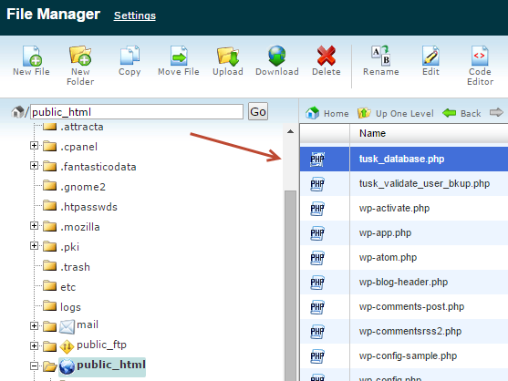

To test: http://thejesustoday.com/tusk_database.php?fct=validate&uname=dpercoco@comcast.net&password=test

http://thejesustoday.com/tusk_database.php?fct=insertRSSDetail&userID=1&title=This%20is%20a%20title&description=This%20is%20a%20description&pubdate=July%2008,2015&url=www.chubb.com&image=comcast.net

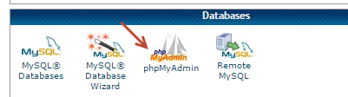
To query against database ,'dpercoco_admin','1nv13rn0'
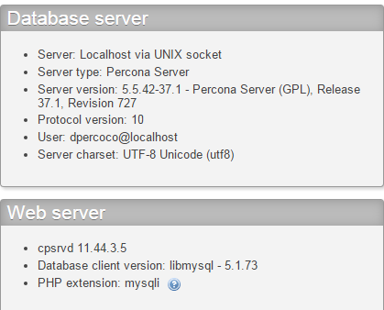
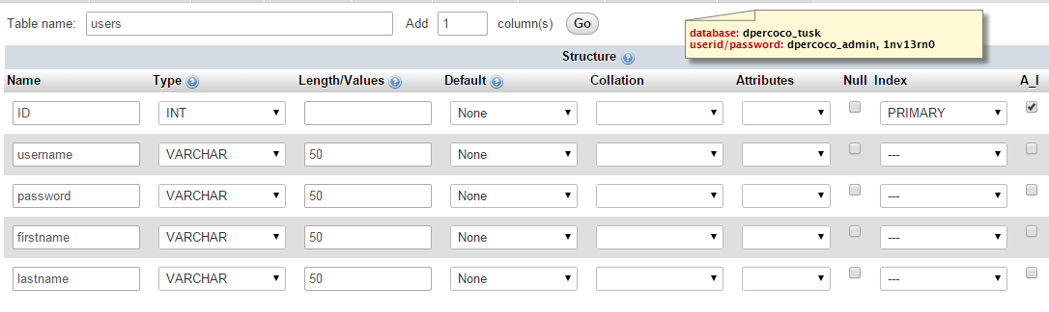
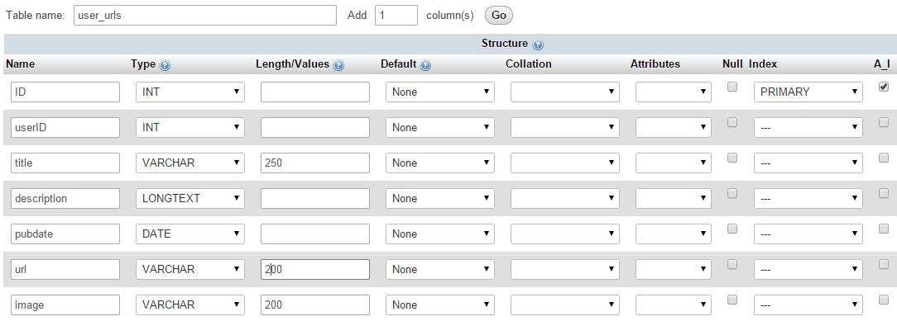

http://samcroft.co.uk/2012/posting-data-from-a-phonegap-app-to-a-server-using-jquery/
https://iphonedevlog.wordpress.com/2014/03/28/populate-your-phonegap-app-with-data-from-an-external-server-db/
http://www.colorzilla.com/gradient-editor/
https://gist.github.com/chales/11359952
http://www.w3schools.com/sql/sql_insert.asp
Issues with launching ADB:

“The connection to adb is down, and a severe error has occured.”

http://stackoverflow.com/questions/26217055/adb-server-didnt-ack

http://stackoverflow.com/questions/4072706/the-connection-to-adb-is-down-and-a-severe-error-has-occured

Failed to install *.apk on device 'emulator-5554': EOF

http://stackoverflow.com/questions/6376722/failed-to-install-apk-on-device-emulator-5554-eof

http://stackoverflow.com/questions/3318738/eclipse-ddms-error-cant-bind-to-local-8600-for-debugger

http://stackoverflow.com/questions/7416139/error-failed-to-install-helloandroid-apk-on-device-emulator-5554

http://stackoverflow.com/questions/13436337/eclipse-juno-no-debug-toolbar

http://stackoverflow.com/questions/8678630/noclassdeffounderror-for-code-in-an-java-library-on-android

Steps to launch within Eclipse:
- From command line: adb kill-server; adb start-server

- Open eclipse (Version: Luna Service Release 2 (4.4.2))
- Right click on AndroidTusk, run as Android Application
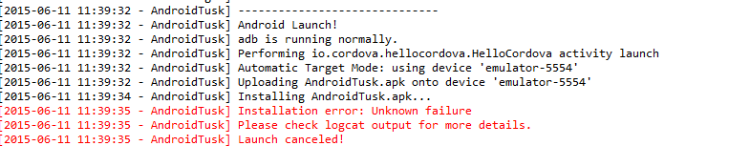
- Launch AVD – NexusOne, unlock device
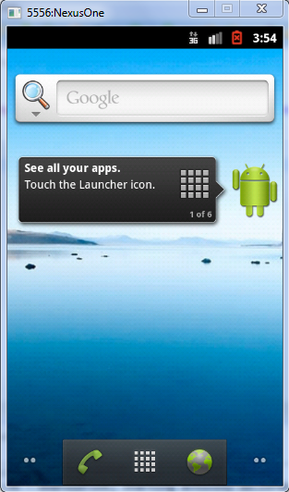
- Right click on AndroidTusk, run as Android Application
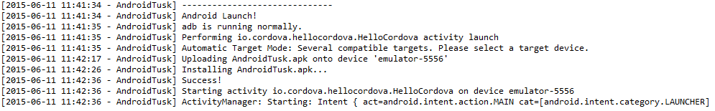
If this issue occurs: REBOOT!!! And follow steps from above.
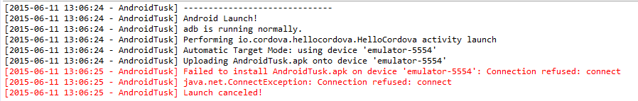
- Close NexusOne & eclipse
- End any “adb” processes in Task Manager
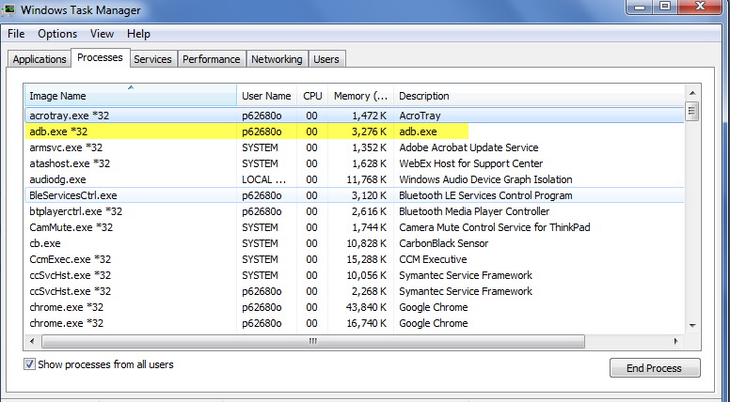
- On command line: adb kill-server, adb start-server
- Open Eclipse, launch AVD Manager, start NexusOne, Unlock device
- Right click on AndroidTusk, run as Android Application

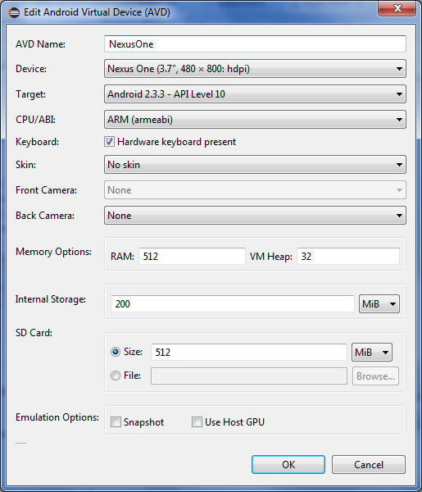
Facebook

App ID: 759720284139421

http://coenraets.org/blog/2014/04/facebook-phonegap-cordova-without-plugin/

https://github.com/ccoenraets/OpenFB

http://www.script-tutorials.com/facebook-api-get-friends-list/

http://michaelbarton.azurewebsites.net/?p=121

http://www.quora.com/How-can-I-use-open-graph-api-FB-get-close-friends-list

https://www.facebook.com/dialog/oauth?client_id=1631549553795045&redirect_uri=https://www.facebook.com/connect/login_success.html&response_type=token&scope=email

https://www.facebook.com/dialog/oauth?client_id=465374093524857&redirect_uri=http://coenraets.org/apps/openfb/oauthcallback.html&response_type=token&display=popup&scope=email

https://developers.facebook.com/docs/reference/fql/user/

http://stackoverflow.com/questions/7596157/how-to-get-a-user-email-from-facebook-graph-api

https://github.com/phonegap/phonegap-facebook-plugin/archive/0.4.0.tar.gz

tar –xvf phonegap-facebook-plugin-0.4.0.tar.gz
cd c:\MyApps\MobileApps\Eclipse\tusk
cordova plugin add c:/users/p62680o/downloads/mobileapps/facebook/phonegap-facebook-plugin-0.4.0/ --variable APP_ID="759720284139421" --variable APP_NAME="Tusk"

http://stackoverflow.com/questions/24695191/facebook-connect-with-phonegap-build-referenceerror-cant-find-variable-face

http://www.sitepoint.com/how-to-integrate-facebook-login-into-a-cordova-based-app/

http://hayageek.com/facebook-javascript-sdk/

https://developers.facebook.com/docs/javascript

Examples:

<< --- Cordova Registry Warning [iOS]
*Installing this plugin directly from Cordova Registry results in Xcode using a brokenFacebookSDK.framework, this is because the current publish procedure to NPM breaks symlinksCB-6092. Please install the plugin through a locally cloned copy or re-add theFacebookSDK.framework to Xcode after installation.*

------------------------------------------ >>

https://github.com/Wizcorp/phonegap-facebook-plugin

plugin add /path/to/here/phonegap-facebook-plugin --variable APP_ID="12345678910" --variable APP_NAME="AwesomeApp"

https://github.com/amirudin/pgb-fbconnect

https://developers.facebook.com/apps/759720284139421/dashboard/

https://github.com/mbrevoort/jquery-facebook-multi-friend-selector

http://www.sitepoint.com/10-jquery-api-tutorials/

http://www.htmlgoodies.com/beyond/javascript/frameworks/using-jquery-and-css3-to-create-a-facebook-multi-friend-selector.html#fbid=2YEYPXeoTwA

$('input[type="submitxx"]').each(function() {
$(this).hide().after('<button>').next().button({
icons: {
primary: 'ui-icon-plusthick',
},
label: $(this).val()
}).click(function(event) {
event.preventDefault();
//$(this).prev().click();
if(!$("#registerForm").valid()) return false;
if (insertUser($('#register_email').val() ,$('#register_password').val(),
$('#register_firstname').val(),$('#register_lastname').val())) {
window.location.href="home.html";
return true;
}
});
});
<div id="confirm" class="ui-content" data-role="popup" data-theme="none">
<p id="question">Are you sure you want to share</p>
<div class="ui-grid-a">
<div class="ui-block-a">
<a id="yes" data-role="button" data-mini="true" data-shadow="false" data-theme="b" data-rel="back">Yes</a>
</div>
<div class="ui-block-b">
<a id="cancel" data-role="button" data-mini="true" data-shadow="false" data-theme="b" data-rel="back">Cancel</a>
</div>
</div>
</div>
SQL Lite
window.sqlitePlugin.openDatabase({ name: 'hello-world.db' }, function (db) {
db.executeSql("select length('tenletters') as stringlength", [], function (res) {
var stringlength = res.rows.item(0).stringlength;
console.log('got stringlength: ' + stringlength);
document.getElementById('deviceready').querySelector('.received').innerHTML = 'stringlength: ' + stringlength;
});
});

<script type="text/javascript" charset="utf-8">
+ document.addEventListener("deviceready", onDeviceReady, false);
+ function onDeviceReady() {
+ var db = window.sqlitePlugin.openDatabase("Database", "1.0", "Demo", -1);
+
+ db.transaction(function(tx) {
+ tx.executeSql('DROP TABLE IF EXISTS test_table');
+ tx.executeSql('CREATE TABLE IF NOT EXISTS test_table (id integer primary key, data text, data_num integer)');
+
+ tx.executeSql("INSERT INTO test_table (data, data_num) VALUES (?,?)", ["test", 100], function(tx, res) {
+ console.log("insertId: " + res.insertId + " -- probably 1"); // check #18/#38 is fixed
+ alert("insertId: " + res.insertId + " -- should be valid");
+
+ db.transaction(function(tx) {
+ tx.executeSql("SELECT data_num from test_table;", [], function(tx, res) {
+ console.log("res.rows.length: " + res.rows.length + " -- should be 1");
+ alert("res.rows.item(0).data_num: " + res.rows.item(0).data_num + " -- should be 100");
+ });
+ });
+
+ }, function(e) {
+ console.log("ERROR: " + e.message);
+ });
+ });
+ }
+ </script>

var MYTIMEOUT = 12000;
var DEFAULT_SIZE = 5000000; // max to avoid popup in safari/ios
// FUTURE TBD replace in test(s):
function ok(test, desc) { expect(test).toBe(true); }
function equal(a, b, desc) { expect(a).toEqual(b); } // '=='
function strictEqual(a, b, desc) { expect(a).toBe(b); } // '==='
var isAndroid = /Android/.test(navigator.userAgent);
var isWindows = /Windows NT/.test(navigator.userAgent); // Windows [NT] (8.1)
var isWP8 = /IEMobile/.test(navigator.userAgent); // WP(8)
// FUTURE:
//var isWindowsPhone = /Windows Phone 8.1/.test(navigator.userAgent); // Windows [NT] (8.1)
var isIE = isWindows || isWP8;
var isWebKit = !isIE; // TBD [Android or iOS]
var scenarioList = [ 'Plugin', 'HTML5' ];
//var scenarioCount = isWebKit ? 2 : 1;
var scenarioCount = 1;
exports.defineAutoTests = function() {
describe('Very simple legacy tests', function() {
for (var i=0; i<scenarioCount; ++i) {
describe(scenarioList[i] + ': simple sql test(s)', function() {
var scenarioName = scenarioList[i];
var suiteName = scenarioName + ': ';
var isWebSql = (i !== 0);
// NOTE: MUST be defined in function scope, NOT outer scope:
var openDatabase = function(name, ignored1, ignored2, ignored3) {
if (isWebSql) {
return window.openDatabase(name, "1.0", "Demo", DEFAULT_SIZE);
} else {
return sqlitePlugin.openDatabase(name, "1.0", "Demo", DEFAULT_SIZE);
}
}
it(suiteName + "US-ASCII String manipulation test", function(done) {
var db = openDatabase("Simple-ASCII-string-test.db", "1.0", "Demo", DEFAULT_SIZE);
expect(db).toBeDefined()
stop();
db.transaction(function(tx) {
expect(tx).toBeDefined()
tx.executeSql("select upper('Some US-ASCII text') as uppertext", [], function(tx, res) {
console.log("res.rows.item(0).uppertext: " + res.rows.item(0).uppertext);
expect(res.rows.item(0).uppertext).toEqual("SOME US-ASCII TEXT");
done();
});
});
});
it(suiteName + 'Simple INSERT test: check insertId & rowsAffected in result', function(done) {
var db = openDatabase("Simple-INSERT-test.db", "1.0", "Demo", DEFAULT_SIZE);
ok(!!db, "db object");
db.transaction(function(tx) {
ok(!!tx, "tx object");
tx.executeSql('DROP TABLE IF EXISTS test_table');
tx.executeSql('CREATE TABLE IF NOT EXISTS test_table (id integer primary key, data text, data_num integer)');
tx.executeSql("INSERT INTO test_table (data, data_num) VALUES (?,?)", ["test", 100], function(tx, res) {
console.log("insertId: " + res.insertId + " -- probably 1");
console.log("rowsAffected: " + res.rowsAffected + " -- should be 1");
ok(!!res.insertId, "Valid res.insertId");
equal(res.rowsAffected, 1, "res rows affected");
done();
});
});
}, MYTIMEOUT);
});
}
});
};

receivedEvent: function(id) {

navigator.splashscreen.hide();
//navigator.notification.alert('Application ready to use', function(){}, 'Ready to use');

var parentElement = document.getElementById(id);
var listeningElement = parentElement.querySelector('.listening');
var receivedElement = parentElement.querySelector('.received');

listeningElement.setAttribute('style', 'display:none;');
receivedElement.setAttribute('style', 'display:block;');

console.log('Received Event: ' + id);
var dbname = "c://MyApps//MobileApps//Eclipse//Tusk//platforms//android//assets//www//tusk.db";
//var db = window.sqlitePlugin.openDatabase(dbname, "1.0", "Tusk", 200000);
//var db = window.sqlitePlugin.openDatabase("tusk.db", "1.0", "Tusk", 200000);
var db = window.sqlitePlugin.openDatabase({name: dbname, createFromLocation: 1});

if (!db) {
console.log("Database not created!");
navigator.notification.alert('Database NOT CREATED', function(){}, 'Ready to use');
tx.executeSql('DROP TABLE IF EXISTS users');
tx.executeSql('CREATE TABLE IF NOT EXISTS users (id integer primary key, firstname text, lastname text)');
tx.executeSql("INSERT INTO users (firstname,lastname) VALUES (?,?)", ["Dahil", "Percoco"],
function(tx, res) {
console.log("insertId: " + res.insertId + " -- probably 1"); // check #18/#38 is fixed
alert("insertId: " + res.insertId + " -- should be valid");

db.transaction(function(tx) {
tx.executeSql("SELECT firstname, lastname from users;", [],
function(tx, res) {
console.log("table length: " + res.rows.length + " -- should be 1");
alert("Name: " + res.rows.item(0).firstname + " " + res.rows.item(0).lastname);
});
}
);
}

db.transaction(function(tx) {
navigator.notification.alert('Using OLD Database', function(){}, 'Ready to use');

tx.executeSql("SELECT firstname, lastname from users;", [],
function(tx, res) {
console.log("table length: " + res.rows.length + " -- should be 1");
alert("Got Name: " + res.rows.item(0).firstname + " " + res.rows.item(0).lastname);
}
);

}, function(e) {
console.log("ERROR: " + e.message);
});
});

//window.sqlitePlugin.closeDatabaseNow("tusk.db");
//db.close();
window.location.href="login.html";

}

$.getJSON('http://www.thejesustoday.com/login_users_select.php', function (response) {

navigator.notification.alert('Invoke', function(){}, 'PHP');
// create a variable to hold the parsed output from the server
var output = [];

// if the PHP script returned a success
if (response.status == 'success') {
// iterate through the response rows
for (var key in response.items) {
// add each response row to the output variable
output.push('<li>' + response.items[key] + '</li>');
navigator.notification.alert('Results', function(){}, response.items[key]);
}

// if the PHP script returned an error
} else {
// output an error message
output.push('<li>No Data Found</li>');
navigator.notification.alert('Results', function(){}, 'No Data Found');
}

// append the output to the `data-role="content"` div on this page as a
// listview and trigger the `create` event on its parent to style the
// listview
$this.children('[data-role="content"]').append('<ul data-role="listview">' + output.join('') + '</ul>').trigger('create');
});

